UCCS
Computer Science Department
CS 701

Online E-Voting System
Software Requirements Specification

2007 UCCS Computer Science Department

Hakan Evecek

Description of Project
Document no: 1
version: 1.0

CONTACT: UCCS
EMAIL: hevecek@uccs.edu

Distribution is subject to copyright.

Disclaimers
The information contained in this document is the proprietary and exclusive property of UCCS except as otherwise indicated. No part of this document, in whole or in part, may be reproduced, stored, transmitted, or used for design purposes without the prior written permission of UCCS.
The information contained in this document is subject to change without notice.
The information in this document is provided for informational purposes only. UCCS Computer Science Department specifically disclaims all warranties, express or limited, including, but not limited, to the implied warranties of merchantability and fitness for a particular purpose, except as provided for in a separate software license agreement.
Privacy Information
This document may contain information of a sensitive nature. This information should not be given to persons other than those who are involved in the E-Voting Online Prototype Tool project or who will become involved during the lifecycle
Version History

REVISION CHART
Version | Author(s) | Description of Version | Date Completed
1.0 | Brett Wilson | Windows Application version | December 2006
2.0 | Hakan Evecek | Online E-Voting Tool | April 2007
2.1 | Hakan Evecek | Online E-Voting Tool Requirements Update | May 2007

Document Owner

The primary contact for questions regarding this document is:
Author: Hakan Evecek
Project Name: Online E-Voting System
Phone: +612-5454-5454
Email: hevecek@uccs.edu
Document Approval

Document Name: Software Requirements Specification for Online E-Voting System
Publication Date: 05/11/2007
Contract Number: N/A
Project Number: 1.0.0
Prepared by: Hakan Evecek

Approval: __________________________
Name and Organization

Concurrence: _________________________
Name and Organization

TABLE OF CONTENTS

1. Introduction 6
1.1 Purpose 6
1.2 Scope 6
1.3 References 7
1.4 Assumptions and Dependencies 7
1.5 Stakeholder Needs 7
1.6 Features 8
2 Use-Case Model Survey : 14
3 Actor Survey 15
4 Requirements 16
4.1 Functional Requirements 16
4.2 Nonfunctional Requirements 25
4.2.1 Usability 26
4.2.2 Reliability 26
4.2.3 Performance 27
4.2.4 Supportability 27
4.2.5 Safety 27
4.2.6 Security 27
5 Online User Documentation and Help System Requirements 27
6 Design Constraints 27
7 Purchased Components 27
8 Interfaces 28
8.1 User Interfaces 28
8.2 Hardware Interfaces 28
8.3 Software Interfaces 28
8.4 Communications Interfaces 28
9 Licensing Requirements 28
10 Legal, Copyright, and Other Notices 28
11 Applicable Standards 28
12 Deliverables 28
13 Open Issues 29
Glossary 30
CAPTCHA - Completely Automated Public Turing test to tell Computers and Humans Apart. Appendix - A 30
Appendix - A 31
Use Case Diagrams: 31
Use Case Diagram #1: 31
Use Case Diagram #2: 31
Use Case Diagram #3: 32
Use Case Diagram #4: 32
Use Case Diagram #5: 33
Use Case Diagram #6: 34
Use Case Diagram #7: 35
Use Case Diagram #8: 36
Appendix - B 37
Use Cases: 37

1. Introduction

1.1 Purpose

The purpose of this document is to describe the behavior of an e-voting System, named Online E-Voting System with Paillier Threshold Crypto (PTC) Web Services.

This system provides an online tool for the clients to vote. In this system there will be two main pages to be able to access: Admin page and Voting Page.

From the Admin page administrator will be able to design the voting application. From the Voting page clients will be able to open their election pages and vote for the candidates.

According to the login credentials, system will determine if the user is Administrator or the user and open the pages given access to the user credentials.

During this tool’s design Paillier Crypto Web Services was used.

1.2 Scope

The main scope of this software is to be able to show the usability of the PTC Web Services and how it can be applied to an online voting tool. Additionally, there will be maintenance processes applied to improve the efficiency of Web services.

The e-voting system to be discussed makes up a relatively small part of the whole
election process. From a technical viewpoint the elections are made up of the following components:
- calling of elections,
- registration of candidates,
- preparation of polling list,
- voting (a subset of which is e-voting),
- Counting of votes.

Other components such as auditing, reviewing of complaints and other supporting activities could be mentioned.
The e-voting system that will be developed assumes: Voter lists have been prepared and are available in a database. User are assigned “User” type and Administrators are assigned “Admin” type. The candidate lists have been prepared and are available in a suitable format and lastly, e-votes are counted separately and are later added to the rest of the votes.
The online e-voting system is made up from: voter lists (including the polling division and constituency assigned to the voter), candidate lists (by constituencies), wxpressed will of the voters.
The output is made up from: Summarized voting result of e-voters and list of voters who used e-voting.

1.3 References

This online e-voting tool is implemented from the project that was about the PTC Web services and done by former UCCS graduate student, Brett Wilson. His project was developing the web services and the demo windows application that showed the functionality of the web services.

B. Wilson, C.Chow, Implementing a Paillier Threshold Cryptography Scheme as a Web Service, University of Colorado at Colorado Springs Master’s Project 2006.

1.4 Assumptions and Dependencies

The software should be developed on Visual Studio 2005. It should run on a Windows environment machine. The PTC Web Service is implemented as an ASP.NET 2.0 Web Service hosted on Microsoft Internet Information Services (IIS) Server. This e-voting prototype will be also built with Windows ASP .NET Forms. This way the whole e-voting solution will be online based. It will require customer’s registration and login. A Microsoft SQL Server database is used to store and retrieve election data. Login details and some efficiency improvements are also done by storing the data in SQL Server. Windows 2003 is the preferred operating system for the server. For the demo Windows XP can also be used.

1.5 Stakeholder Needs
ID of Need 1
Description: A login page is required to validate the user
ID of Need 2
Description: Administrators will be connected to the Admin Page.
ID of Need: 3
Description: Administrator can create an Election Page.
ID of Need: 4
Description: : Administrator can create a ballot.
ID of Need 5
Description: Administrator will be able to add the list of the users for voting.
ID of Need: 6
Description: Administrator will be able to send and establish encryption with PTC Web Services.
ID of Need 7
Description: Users will choose the election to vote.
ID of Need 8
Description: Users will vote.
ID of Need 9
Description: : Users will view the submitted vote.
ID of Need 10
Description: The system will allow Administrator to Tally votes.
ID of Need 11
Description: The system must use few and reliable resources. It must be fast.
ID of Need 12
Description: The system maintenance must be very easy.
ID of Need 13
Description: The machine can run on any Windows machine with the same rights and permissions setup as the other systems on the network.
ID of Need 14
Description: The system performance must be reliable and must be very easy to access in less then couple of seconds from the internet.

1.6 Features
SET OF FEATURES RELATED TO NEED 1
ID of Feature 11
Title: Enter user login details.
Description: Username and password fields are required to be able to login.
ID of Feature 12
Title: A button for the help menu for the login page.
Description: Login instructions will be explained in this help link.
SET OF FEATURES RELATED TO NEED 2
ID of Feature 21
Title: Administrator page will have Admin links.
Description: Administrator will need to have Admin links available from this page.
ID of Feature 22
Title: Voting can be done from this page.
Description: Administrator will have a link to the voting form from this page.
ID of Feature 23
Title: Election creation and modification link will be from the Admin page.
Description: : Administrator will have a link to create or modify an election.
ID of Feature 24
Title: Election Tally and decryption will have a link from this form.
Description: Administrator will have a link to Tally and to decrypt votes from this form.
ID of Feature 25
Title: Help link for the Admin page needs to be displayed.
Description: Administrator will need to have a link for the Admin help menu.
ID of Feature 26
Title: New Ballot creation Link for the Admin page needs to be displayed.
Description: Administrator will need to have a link for creating new ballots from the Admin pages.
SET OF FEATURES RELATED TO NEED 3
ID of Feature 31
Title: New Election Button.
Description: Administrator will be able to create a new election.
ID of Feature 32
Title: Open an existing Election.
Description: Administrator can open an existing election.
ID of Feature 33
Title: Populate the election unique ID field.
Description: : Election ID will be created, possibly with a random generator class.
ID of Feature 34
Title: Add Election details into the election form.
Description: Election Administrator, election Title: etc.
ID of Feature 35
Title: Ballots creation, posting election details will be enabled during this process.
Description: Once election fields are populated, ballots and posting election details buttons will be enabled to be able to create the election forms for voting.
SET OF FEATURES RELATED TO NEED 4
ID of Feature 41
Title: Add a new ballot.
Description: Administrator will be able to add a new ballot into the system.
ID of Feature 42
Title: Open an existing ballot.
Description: Ballots will be saved in xml format and Administrator will be able to open an existing ballot to add to the election.
ID of Feature 43
Title: Save the new ballot.
Description: : Save the new created ballot to be able to use in the other elections.
SET OF FEATURES RELATED TO NEED 5
ID of Feature 51
Title: Add list of the users joining to the election.
Description: Once election is created or opened, adding users buttons will be enabled.
ID of Feature 52
Title: Choose the encryption key for the users that will use encryption.
Description: If the users will use encryption key, make sure that encryption checkbox is enabled and choose the encryption file from the list.
ID of Feature 53
Title: Send request to the threshold crypto web services.
Description: All the user information and election details will be sent and processed through the Threshold Crypto Web services.
ID of Feature 54
Title: Created output will be displayed in xml format
Description: Created output and encryption details will be displayed on a text window.
SET OF FEATURES RELATED TO NEED 6
ID of Feature 61
Title: Send Election request to the PTC Web Services.
Description: Created Election Form, ballots list etc will be sent to the PTC Web Services to Post the Election.
ID of Feature 62
Title: Have a back to the main page link.
Description: If required Administrator should be able to return to the main menu page.
SET OF FEATURES RELATED TO NEED 7
ID of Feature 71
Title: Open Election to vote.
Description: Elections will be selected from the xml files.
ID of Feature 72
Title: Display Election ID details.
Description: Election ID will be displayed in the ID field.
ID of Feature 73
Title: Rest of the election details stored will be displayed in the fields.
Description: : Ballots and election questions will be displayed in the fields. .
SET OF FEATURES RELATED TO NEED 8
ID of Feature 81
Title: Enter Voter Name.
Description: Voter Name will be entered.
ID of Feature 82
Title: List Box to show the election questions.
Description: One list box will show the election questions to choose from the ballots list to vote.
ID of Feature 83
Title: Vote candidates will be displayed for the chosen ballot.
Description: : Choose the candidate for the highlighted ballot.
ID of Feature 84
Title: Chosen candidate will be displayed.
Description: Candidate chosen will be displayed with the ballots details. If the voters decides to change for any reason before submitting the vote it can be updated.
ID of Feature 85
Title: Submit vote.
Description: Submit vote button will be available for user to submit vote details.
SET OF FEATURES RELATED TO NEED 9
ID of Feature 91
Title: Submitted votes can be displayed on another form.
Description: Log the messages after each system is loaded and store them in a text file.
ID of Feature 92
Title: Unique Election ID will be displayed.
Description: Unique Election ID will be displayed
ID of Feature 93
Title: Submitted vote details will be displayed.
Description: Voting details will be displayed in a text box or a list box.
SET OF FEATURES RELATED TO NEED 10
ID of Feature 101
Title: Administrator can access to the Tally Votes page.
Description: Administrator will have access to the Tally Votes page via a link from the administrator’s page to open the form.
ID of Feature 102
Title: Open Election.
Description: Election will be opened from the elections XML list.
ID of Feature 103
Title: Election ID will be displayed.
Description: : Unique election ID will be displayed.
ID of Feature 104
Title: Election and Ballot details will be displayed.
Description: Election and ballot details will be displayed in a text field.
ID of Feature 105
Title: Retrieve votes
Description: Votes can be retrieved from the database by PTC Web services.
SET OF FEATURES RELATED TO NEED 11
ID of Feature 111
Title: Network Resources needs to be reliable.
Description: This online application relies on database connections and network (internet) connections on a lot of features. Network can be monitored and errors can be reported when there is a network connectivity issue.
ID of Feature 112
Title: It must be fast to process the request.
Description: Especially when the application is processing the data, there might be some instances where some data needs to be transferred. The design needs to be done by making sure that online application will operate fast.
SET OF FEATURES RELATED TO NEED 12
ID of Feature 121
Title: Online e-voting system maintenance must be easy.
Description: Online e-voting system involves few different components. Each of these components might require maintenance and applying these changes should be relatively easy.
ID of Feature 122
Title: Update schemas and the code for the new changes must be easy.
Description: As this tool is an online e-voting system and there might be new changes required, any new additions or changes need to be implemented easily. Database schemas need to be updated; code changes might be required for the new fields.
SET OF FEATURES RELATED TO NEED 13
ID of Feature 131
Title: Online application should run from any windows machine that has internet access.
Description: E-voting online application should run from any machine that has online access.
ID of Feature 132
Title: Some of the forms require database access and this access should be easy to establish.
Description: : Forms require database access should be able to easily access to the databases.
SET OF FEATURES RELATED TO NEED 14
ID of Feature 141
Title: System performance must be reliable.
Description: As this is an online application and will be accessible from the internet, system performance should be reliable.
ID of Feature 142
Title: Must be very easy to access via online.
Description: E-voting system must be very easy to access via online in a couple of seconds. Response time to submit the votes shouldn’t be more than 30-40 seconds.

2 Use-Case Model Survey :

3 Actor Survey

Actors:
ID of Actor 1
Name: Voter
Description: The person who interacts with the online application to vote
ID of Actor 2
Name: Administrator
Description: The person who interacts with the online application to manage the elections.
ID of Actor 3
Name: Database Server
Description: This is the server where we host the data.
ID of Actor 4
Name: Server
Description: This is the server where we host the web based application.
ID of Actor 5
Name: Network
Description: This application requires Network connection from the Server.

ID of Actor 6
Name: Internet
Description: This application requires internet connection from the Server.

ID of Actor 7
Name: Ballot XML File
Description: Ballot XML Files are required to be able to keep the saved ballot details.

ID of Actor 6
Name: Election XML File
Description: Election XML Files are required to be able to keep the saved Election details.

4 Requirements

4.1 Functional Requirements

The needs, features, requirements, actors and use-cases shown in this SRS document were captured. Use cases are listed in the Appendix - A.

Functional Requirements
SET OF FUNC. RQMTS RELATED TO NEED 1
TO FEATURE 11
ID of F Rqmt 111
Title: Create a username entry box
Description: Have this username field limited to 15 characters entry.
ID of F Rqmt 112
Title: Create a password entry box
Description: Have this password field limited to 15 characters entry and hidden text field.
ID of F Rqmt 113
Title: Text box to validate the random numbers generated.
Description: Due to the spam and hackers, a random number generator will be used and this number will be displayed on an image for uses to type in for an additional validation. Completely Automated Public Turing test to tell Computers and Humans Apart (CAPTCHA) will be used for this.

TO FEATURE 12
ID of F Rqmt 121
Title: Have a link enabled to connect to the help menu.
Description: Help menu link will be required.
ID of F Rqmt 122
Title: Login details will be provided in this help link.
Description: This help link will open another form which explains login page access details.
SET OF FUNC. RQMTS RELATED TO NEED 2
TO FEATURE 21
ID of F Rqmt 211
Title: Administrator page setup
Description: Administrator will need to have access to e-voting administrative pages.
ID of F Rqmt 212
Title: Help menu needs to be provided
Description: Help menu needs to be provided to be able to access the links Description:s.
TO FEATURE 22
ID of F Rqmt 221
Title: Voting link for the Administrator
Description: Administrator should be able to access to the voting link from the admin page.
TO FEATURE 23
ID of F Rqmt 231
Title: Election creation link
Description: Administrator will need to access to the Election creation link.
ID of F Rqmt 232
Title: Election modification
Description: Administrator will need to access to the modification link.
TO FEATURE 24
ID of F Rqmt 241
Title: Tally Vote link
Description: Administrator will need to have access to tally the votes.
ID of F Rqmt 241
Title: Decrypt Vote link
Description: Administrator will need to have access to use decryption option for the encrypted votes.
TO FEATURE 25
ID of F Rqmt 251
Title: Help link for all the links
Description: Administrator will need a link for the help menu.

TO FEATURE 26
ID of F Rqmt 261
Title: New Ballot creation link
Description: Administrator will need a link for creating new ballots in the Administrator page.

SET OF FUNC. RQMTS RELATED TO NEED 3
TO FEATURE 31
ID of F Rqmt 311
Title: New Election Button
Description: Administrator will need a button to be able to use for a new election creation.
ID of F Rqmt 312
Title: Rest of the buttons in the page will be disabled.
Description: Creating users, sending the requests to PTC and posting the election buttons will be disabled initially. They will be enabled during the future stages of the election creation.
TO FEATURE 32
ID of F Rqmt 321
Title: Open an Existing Election Button
Description: One of the previously saved elections can be opened to modify.
ID of F Rqmt 322
Title: Access to the elections folder
Description: Open an election xml file.
TO FEATURE 33
ID of F Rqmt 331
Title: Populate an Election ID for the new election.
Description: New button will generate a new election ID by using the web services.
ID of F Rqmt 332
Title: Get Election ID details
Description: Get election ID details from the existing election xml files.
TO FEATURE 34
ID of F Rqmt 341
Title: Election Administrator
Description: Election Administrator name maximum 50 characters.
ID of F Rqmt 342
Title: Election Title:
Description: Election Title: maximum 50 characters.
TO FEATURE 35
ID of F Rqmt 351
Title: Enable ballots creation
Description: Ballots creation button will be enabled after Election details are collected.
ID of F Rqmt 352
Title: Enable posting election details button
Description: Posting election details button will be enabled after Ballot details are collected.
ID of F Rqmt 353
Title: Enable ballots creation
Description: Ballots creation button will be enabled after Election details are collected.
ID of F Rqmt 354
Title: Enable Adding new users button
Description: Adding new users button will be enabled after Election details are entered.
SET OF FUNC. RQMTS RELATED TO NEED 4
TO FEATURE 41
ID of F Rqmt 411
Title: Add a new ballot.
Description: Open a ballot builder form.
ID of F Rqmt 412
Title: Assign a ballot ID in the ballot builder form.
Description: A Ballot ID will be assigned for the new ballot we will be creating.
ID of F Rqmt 413
Title: Define the question or issue.
Description: Question or issue that will be asked during the ballot needs to be defined.

ID of F Rqmt 414
Title: Add choices for the answers or options to be chosen.
Description: Add choices for the answers or options to be chosen for the issue or question.
ID of F Rqmt 415
Title: Display the format of the ballot created.
Description: Display the view of the ballot on a separate text window.
TO FEATURE 42
ID of F Rqmt 421
Title: Open an existing ballot.
Description: Open an existing created ballot from the ballots folder of the web server.
ID of F Rqmt 422
Title: Display details of the ballot.
Description: Display details of the ballot on a text window.
TO FEATURE 43
ID of F Rqmt 431
Title: Enable Save the new ballot button.
Description: Enable save new ballot button after the details are entered.
ID of F Rqmt 432
Title: Save the new ballot
Description: Save the new ballot on an xml file in the ballots folder.
SET OF FUNC. RQMTS RELATED TO NEED 5
TO FEATURE 51
ID of F Rqmt 511
Title: Enter new username.
Description: Enter new username into the text box that has 30 character limitations.
ID of F Rqmt 512
Title: Enable encryption button.
Description: Enable add encryption button for the user.

TO FEATURE 52
ID of F Rqmt 521
Title: Check box is required to enable the user’s encryption
Description: Checkbox is required to be able to enable the user’s encryption.
ID of F Rqmt 522
Title: Encryption size key.
Description: Encryption size key is required to be able to send request if the user encryption is enabled.
ID of F Rqmt 523
Title: Display users list.
Description: Display added users list on a separate text box.
TO FEATURE 53
ID of F Rqmt 531
Title: Send request to PTC web services button enabled.
Description: Enable send request to PTC.
ID of F Rqmt 532
Title: Process request by using the PTC Web services.
Description: Connect to PTC Web services and process the election and users request before adding the ballots.
TO FEATURE 54
ID of F Rqmt 541
Title: Display user details and election details on an xml format.
Description: Display user details and election details on an xml format on a separate text box.
ID of F Rqmt 542
Title: Define xml format
Description: Owner info, secret shared key, Paillier verification parameters etc. will be part of this xml file created by the send request button.

SET OF FUNC. RQMTS RELATED TO NEED 6
TO FEATURE 61
ID of F Rqmt 611
Title: Post Election to Voting Service button
Description: After the election is created and saved, it will need to be posted to the voting web services.
ID of F Rqmt 612
Title: Process election details
Description: Election created will be processed and including ballot details info will be put into the database.
TO FEATURE 62
ID of F Rqmt 621
Title: Link back to the main page.
Description: Back to the main page is required as Administrator might need to access to another form. He might try to access voting pages for testing from the menu.
SET OF FUNC. RQMTS RELATED TO NEED 7
TO FEATURE 71
ID of F Rqmt 711
Title: Open Election to vote.
Description: After user logs in, user opens the election form.
ID of F Rqmt 712
Title: Connect to the elections on the server
Description: Connect to the elections folder where all the elections are saved on an xml format.
TO FEATURE 72
ID of F Rqmt 721
Title: Get Election ID
Description: Get election details from the xml file.
ID of F Rqmt 722
Title: Display Election ID
Description: Display Election ID on the text box from the xml file.
TO FEATURE 73
ID of F Rqmt 731
Title: Display Election details
Description: Connect to xml and get all election details.
ID of F Rqmt 732
Title: Display Election Administrator
Description: Display Election Administrator details.
ID of F Rqmt 733
Title: Display Election Title
Description: Display Election Title details.
SET OF FUNC. RQMTS RELATED TO NEED 8
TO FEATURE 81
ID of F Rqmt 811
Title: Username Entry
Description: User who will be voting will need to enter the username.
TO FEATURE 82
ID of F Rqmt 821
Title: Show the election questions.
Description: Election questions will be shown in a list box or a text box.
TO FEATURE 83
ID of F Rqmt 831
Title: Issue or question ballots will be displayed.
Description: Each issue or questions will have candidates to be chosen.
ID of F Rqmt 832
Title: Update candidate list for the selected item.
Description: Update candidates list according to the selected issue or problem..
TO FEATURE 84
ID of F Rqmt 841
Title: Display voting details.
Description: Display e-voting details for the user.
ID of F Rqmt 842
Title: Update voting display text box.
Description: Each time selected item has changed, voting display box will need to be updated according to the selections.
TO FEATURE 85
ID of F Rqmt 851
Title: Enable submit Vote button
Description: All buttons on this form including the Submit vote button needs to be enabled. .
ID of F Rqmt 852
Title: Votes will be submitted via PTC web services.
Description: Votes will be submitted via PTC web services and stored in the database.

SET OF FUNC. RQMTS RELATED TO NEED 9
TO FEATURE 91
ID of F Rqmt 911
Title: Submitted Vote Form display
Description: After the votes are submits, submitted form display form will be shown to the user.
ID of F Rqmt 912
Title: Voter name will be displayed.
Description: Voter name will be displayed on the submitted vote page.
TO FEATURE 92
ID of F Rqmt 921
Title: Election ID will be displayed.
Description: Election ID will be passed and displayed on the submitted vote form.
TO FEATURE 93
ID of F Rqmt 931
Title: Submitted vote details will be displayed.
Description: Last voter’s submitted votes’ details will be displayed on a text box or a list box.
ID of F Rqmt 932
Title: Thank you for using the e-voting systems message display.
Description: At the end of the voting process a Thank you message will be displayed to the user.
SET OF FUNC. RQMTS RELATED TO NEED 10
TO FEATURE 101
ID of F Rqmt 1011
Title: Tally Votes Form will be displayed.
Description: Administrator will have an access to the Tally Votes form from the admin page. When the link is clicked Tally Votes Form will be displayed.
TO FEATURE 102
ID of F Rqmt 1021
Title: Open Election
Description: Elections folder will be accessed for Administrator to open the election he will be tallying the votes.
ID of F Rqmt 1022
Title: Elections folder will be the default folder
Description: Elections folder will be the default folder to access.

TO FEATURE 103
ID of F Rqmt 1031
Title: Election ID
Description: Unique Election ID will be displayed from the Tally Votes Form.

TO FEATURE 104
ID of F Rqmt 1041
Title: Election Details will be displayed.
Description: Election ID field will be displayed.
ID of F Rqmt 1042
Title: Ballots will be displayed on a list box.
Description: Ballots will be displayed on a list box where Administrator will be able to choose the question and ballot options will be shown with the tally details.
ID of F Rqmt 1043
Title: Encrypted votes will be displayed on separate text box.
Description: Encrypted votes will be displayed on separate text box.
TO FEATURE 105
ID of F Rqmt 1051
Title: Vote results will be retrieved
Description: Results will be retrieved from the database.
ID of F Rqmt 1052
Title: Encrypted and Decrypted results will be displayed on separate text boxes.
Description: Encrypted and Decrypted results will be displayed on separate text boxes.

4.2 Nonfunctional Requirements

SET OF NON-FUNC. RQMTS RELATED TO NEED 11
TO FEATURE 111
ID of Non-Func. Rqmt 1111
Title: Network Resources needs to be reliable.
Description: This online e-voting system uses internet connectivity to be able to communicate with the web services and relies heavily on network connectivity. Network can be monitored and errors can be reported when there is a network connectivity issue.
ID of Non-Func. Rqmt 1112
Title: It must be reliable to process the database request.
Description: Especially when the application is processing the data, database connections must be reliable.
TO FEATURE 112
ID of Non-Func. Rqmt 1121
Title: It must be fast to process the request.
Description: Especially when the application is processing the data, there might be some instances where a lot of data needs to be transferred. The design needs to be done by making sure that application will operate fast.
SET OF NON-FUNC. RQMTS RELATED TO NEED 12
TO FEATURE 121
ID of Non-Func. Rqmt 1211
Title: System maintenance must be easy.
Description: System will be used be using some additional components. Each of these components might need an update or changes. Applying these changes during the maintenance should be relatively easy.

TO FEATURE 122
ID of Non-Func. Rqmt 1221
Title: Update schemas and the code for the new changes must be easy.
Description: As this tool is an online e-voting system and there might be new changes required, any changes need to be implemented easily. Schemas need to be updated; code changes will be required for the new fields.

SET OF NON-FUNC. RQMTS RELATED TO NEED 13
TO FEATURE 131
ID of Non-Func. Rqmt 1311
Title: Online e-voting application should run from any machine that has internet connectivity.
Description: Internet connectivity is required to be able to run the online tool. It should be able to run from any machine that has online connectivity.
ID of Non-Func. Rqmt 1312
Title: Online application should be able to access to PTC Web services running from the web server.
Description: All the forms require PTC Web services access should be able to access easily.

TO FEATURE 132
ID of Non-Func. Rqmt 1321
Title: Some of the forms requires database access via internet connection.
Description: Forms require database access should be able to easily access to the database via internet.

SET OF NON-FUNC. RQMTS RELATED TO NEED 14
TO FEATURE 141
ID of Non-Func. Rqmt 1411
Title: System performance must be reliable.
Description: This is online application and there might be many users accessing the resources online. Performance should be reliable.
TO FEATURE 142
ID of Non-Func. Rqmt 1421
Title: Access to any internet resources must be very easy.
Description: Any features require internet access shouldn’t take longer than 30-40 seconds.

4.2.1 Usability

It is expected that the user should be able to vote easily online. Administration of the page also should be user friendly. Provide step by step guide for both admin and users. User should complete voting in a few minutes. Provide an online help. Provide also a quick guide for users.

4.2.2 Reliability

The system should be reliable. Security is a major concern for an e-voting system. Process used in this system should be secure enough to be able to meet the requirements mentioned for e-voting. It requires database connections and network connections. Changes can be done in the databases to store the votes. All changes needs to be confirmed and if the transfer is complete the confirmation should be displayed. The changes should be monitored.

4.2.3 Performance

There might be many users accessing to the web server simultaneously. As an online e-voting tool performance shouldn’t be affected much and response time for submitted page should be less than a minute.

4.2.4 Supportability

Version 1.0.0.0 is the first version of the e-voting system. Future release features will be considered during the design. Phone support can be provided with all dial in details in the initial version release. In the future versions this can be improved by supporting an online chat facility. Future enhancements or improvements can be considered during the design and development.

4.2.5 Safety

Web server should be secure. Regular backups should be in place.

4.2.6 Security

Customer’s voting is secure. Customer’s registration information is confidential.

5 Online User Documentation and Help System Requirements

Voting system user guide will be online. Initial version will have phone support available.

6 Design Constraints

Voting system will be an online application and it can run from a machine that has an internet access. For the web services setup, .Net Framework 2.0 and SQL 2005 required. Preferred web server’s operating system is Windows 2003. Internet connectivity is required. The online e-voting application needs to be designed for a non-technical user. It should have specific instructions online. Non-technical users will be involved in testing to make sure that they can complete the process without any problems. Database access and web services access are required.

7 Purchased Components

For this project, to be able to store the requirements, use cases, design and project model all in the same tool, Enterprise Architecture 6.5 will be used. Visual Studio 2005 and SQL Server 2005 is other development tool to use.

8 Interfaces

8.1 User Interfaces

Main Screen:

It will have a login screen. Login screen will have additional Completely Automated Public Turing test to tell Computers and Humans Apart (CAPTCHA) based security check to minimize the spam and attacks to the pages.

Admin logins will be connected to the Administrator pages where they can access Election, Ballots, and Tally and help menus for e-voting.

8.2 Hardware Interfaces

As this application can be accessed via internet, only web server is required as a hardware interface to be able to run it. It is assumed that web server is in a secure environment with necessary firewall and network setting done.

8.3 Software Interfaces

IIS needs to be installed on the web server.

8.4 Communications Interfaces

None.

9 Licensing Requirements

Licensed to UCCS – Dr. Edward Chow.
CS701 Fall 2006 – Brett Wilson and CS701 Spring 2007 – Hakan Evecek.

10 Legal, Copyright, and Other Notices

None.

11 Applicable Standards

There are no applicable standards.

12 Deliverables
A hard copy every document in this project as listed below will be delivered on the project presentation date.
The files below are all on the web site below:
http://cs.uccs.edu/~gsc/pub/master/hevecek/doc/

- CS701Proposal_EVotingPrototype.doc
This document describes what the project would be for the advisory committee. It was submitted in February 2007.

- EVoting_SRS Document.doc
This is the online E-Voting prototype System Requirements Specification document for the project. Demonstration windows application created used to get the requirements for this tool. It has all the use cases.

- EVoting_SDS Document.doc
This describes the internal design of the project. This document has both black box and white box designs. Also class diagrams from the web services are also prepared for documenting although they were developed previously. It has the main use cases to make it easier to create the SDS. It also involves database design.

- EVoting_Test Plan.doc
The tests for the project are documented in this document. Test plans cover all the requirements testing.

- Online E-Voting Prototype with PTC Web Services.doc
This is the project report document. It is the final report for the project that has discussions about e-voting system. There are some e-voting related papers researched about the online e-voting system implementation and I tried to explain why it is so hard to implement, develop and deploy today by using these papers. Also in this report for the PTC design section and PTC develop description, [15] is used. Lastly, some efficiency improvements applied in the code and according to the results that will be explained, it has improved.

- Paillier ThresholdCryptoService_UserGuide_Updated.doc
This document that is the user guide for the PTC web services.

Source files for the code is placed in the link below:
http://cs.uccs.edu/~gsc/pub/master/hevecek/src/

13 Open Issues
N/A

Glossary

CLASS – a set of packets receiving better QoS than packets from lower classes.

QUALITY OF SERVICE (QoS) – to provide less waiting time to packets that need server utilization.

SOFTWARE – E-Voting Online Application.

CAPTCHA - Completely Automated Public Turing test to tell Computers and Humans Apart.

Appendix - A
Use Case Diagrams:

Use Case Diagram #1:
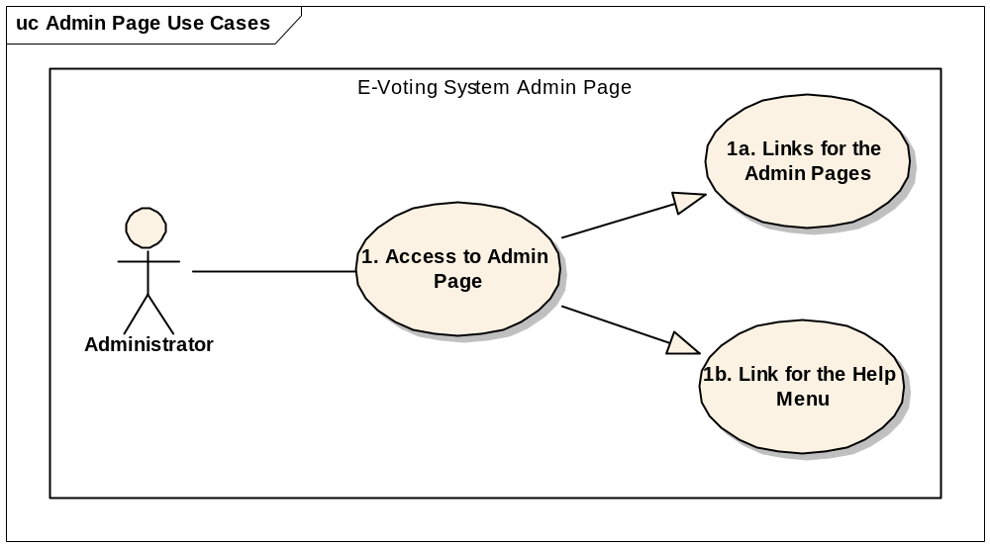

Use Case Diagram #2:

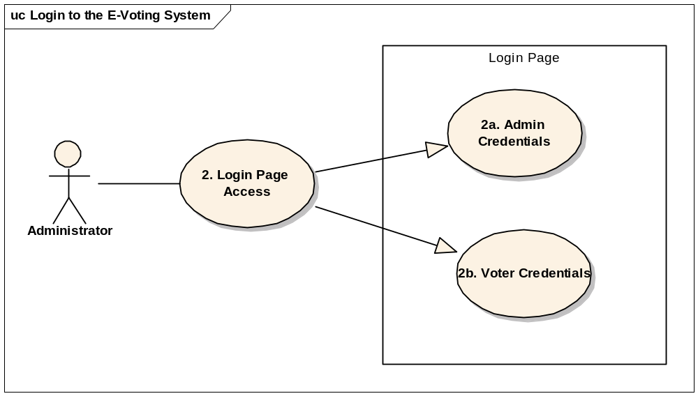
Use Case Diagram #3:

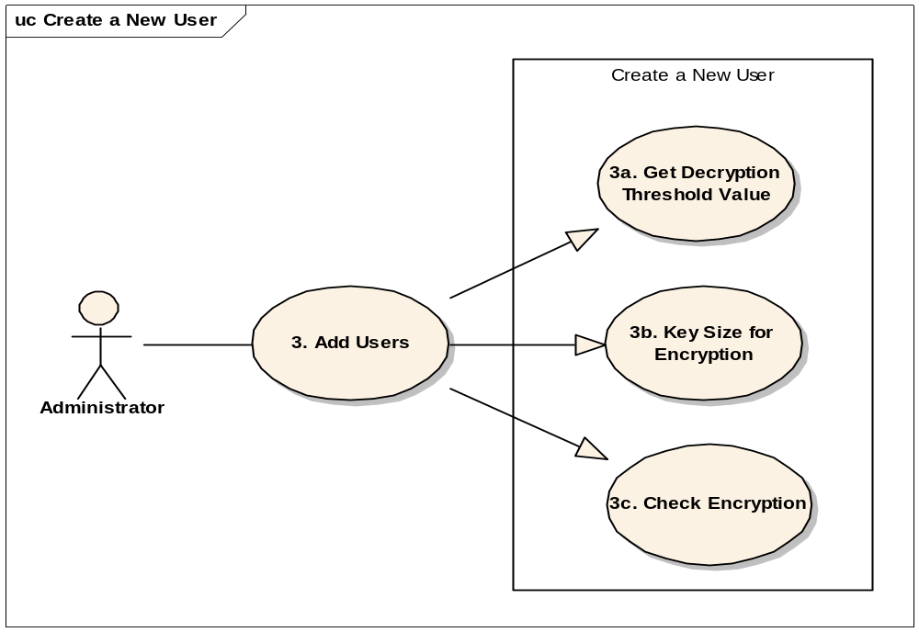
Use Case Diagram #4:

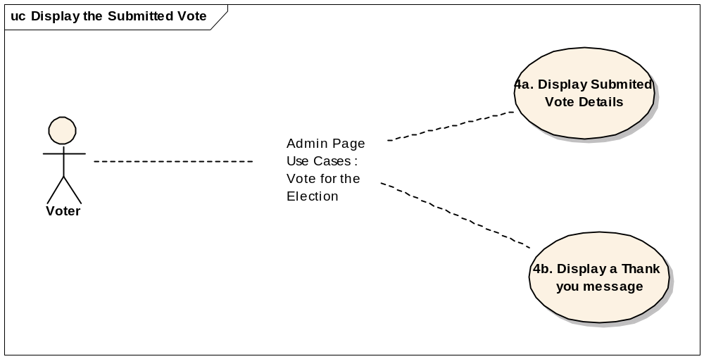
Use Case Diagram #5:

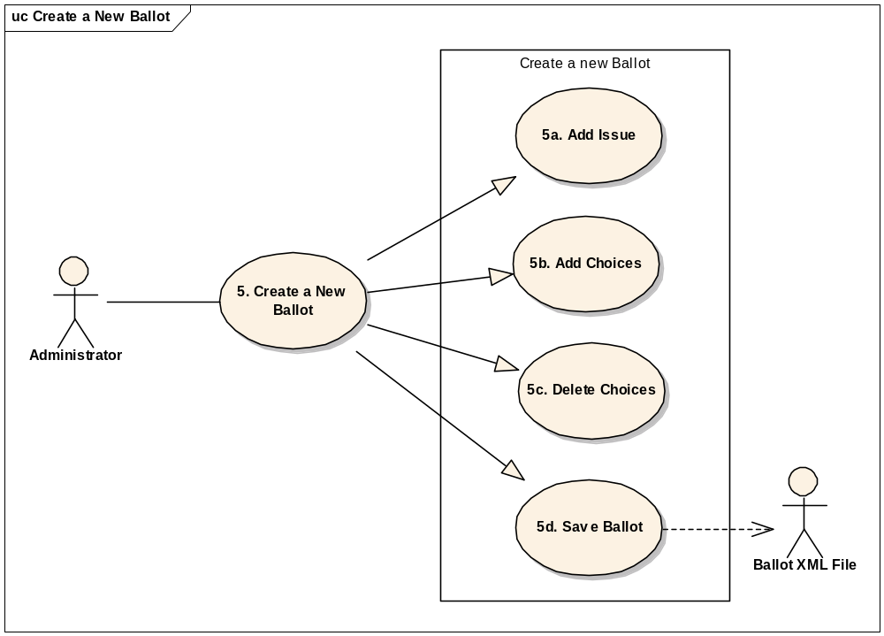
Use Case Diagram #6:

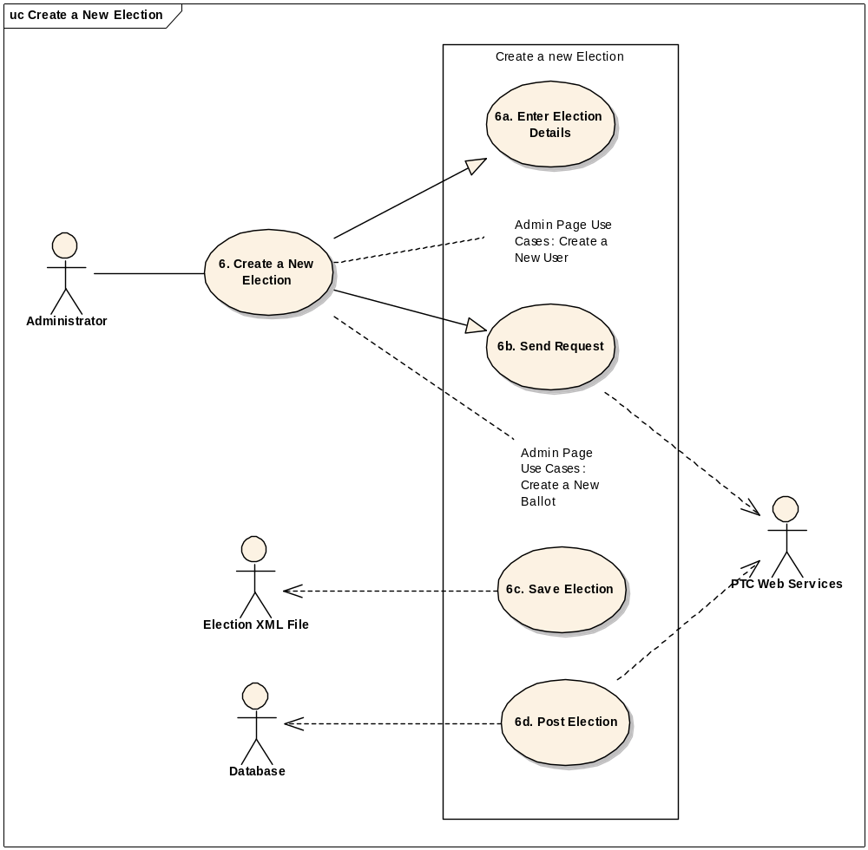

Use Case Diagram #7:

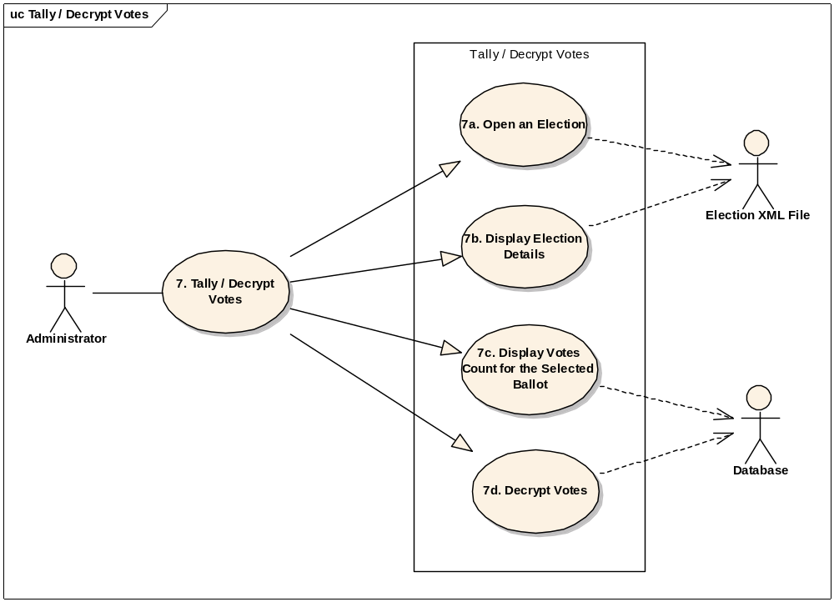

Use Case Diagram #8:

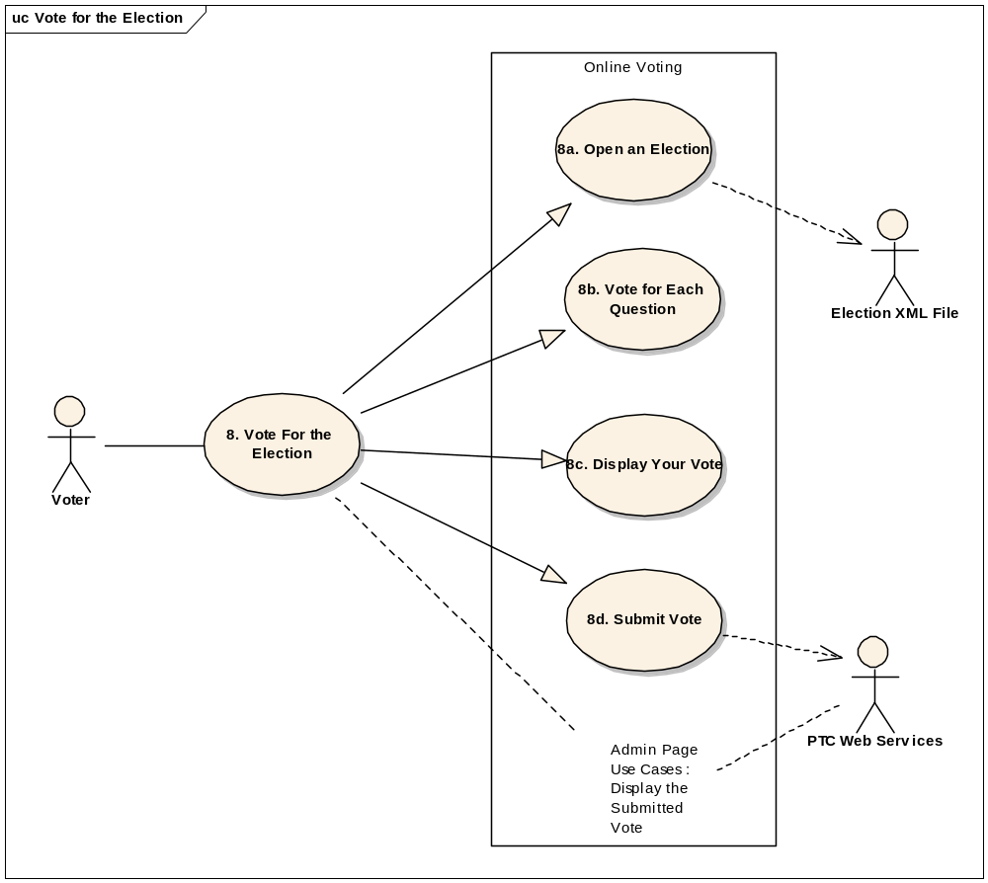

Appendix - B
Use Cases:

Use Case ID: | 1
Use Case Name: | Access to Admin Page
Created By: | Hakan Evecek | Last Updated By: | Hakan Evecek
Date Created: | 03/14/2007 | Date Last Updated: | 04/15/2007

Primary Actors: | Administrator
Secondary Actors: | N/A
Description: | This use case describes how to access to the Admin page.
Trigger: | Administrator requires managing the Election pages.
Preconditions: | Actor Network is idle. Actor internet is idle.  Actor Database is idle.
Postconditions: | Administrator will have an admin page to be able to connect and manage.
Normal Flow: | Administrator logs in and connects to the Administrator page where he will have access to create a new election, modify an election, voting, tally and/or decrypt the votes. Connect to the network via actor network. Connect to the database via actor database.
Alternative Flows: | None.
Exceptions: | When there is a network problem create an error and report it .  When there is a database connectivity problem report the problem via Error Messaging Technique.
Includes: | None
Priority: | High
Frequency of Use: | High
Business Rules: | None
Special Requirements: | Only certain users can have access to this page. It will require administrator privileges to open it.
Open Issues | None
Assumptions: | Server or desktop using online e-voting has a network and internet connection.
Notes and Issues: | Any internet connection or network connection issue will cause access problems.

Use Case ID: | 1a
Use Case Name: | Links for the Admin Pages
Created By: | Hakan Evecek | Last Updated By: | Hakan Evecek
Date Created: | 03/14/2007 | Date Last Updated: | 04/15/2007

Primary Actors: | Administrator
Secondary Actors: | N/A
Description: | This use case defines accessing to the Admin pages links.
Trigger: | Administrator requires managing the Election pages. He will need to access to Administration pages
Preconditions: | Actor Network is idle. Actor internet is idle.
Postconditions: | Administrator will have an admin page to be able to connect and manage.
Normal Flow: | Administrator logs in and connects to the Administrator page where he will have access to create a new election, modify an election, voting, tally and/or decrypt the votes. Connect to the network via actor network.
Alternative Flows: | None.
Exceptions: | When there is a network problem create an error and report it .
Includes: | None
Priority: | High
Frequency of Use: | High
Business Rules: | None
Special Requirements: | Only certain users can have access to this page. It will require administrator privileges to open it. After the user accesses the page, he will be able to use all the links on this page.
Open Issues | None
Assumptions: | Server or desktop using online e-voting has a network and internet connection.
Notes and Issues: | Any internet connection or network connection issue will cause access problems.

Use Case ID: | 1b
Use Case Name: | Link for the Help Menu
Created By: | Hakan Evecek | Last Updated By: | Hakan Evecek
Date Created: | 03/14/2007 | Date Last Updated: | 04/15/2007

Primary Actors: | Administrator
Secondary Actors: | N/A
Description: | This use case describes how to access to the Admin page.
Trigger: | Administrator might need to use the help menu for link descriptions.
Preconditions: | Actor internet is idle.
Postconditions: | Administrator will use the help menu.
Normal Flow: | Administrator will have access to the help menu link. When he clicks to the link he will have access to the help page that will have descriptions of all the links on the page.
Alternative Flows: | None.
Exceptions: | When there is a network or internet connectivity problem create an error.
Includes: | None
Priority: | High
Frequency of Use: | High
Business Rules: | None
Special Requirements: | Only certain users can have access to this page. It will require administrator privileges to open it.
Open Issues | None
Assumptions: | Server or desktop using online e-voting has a network and internet connection.
Notes and Issues: | Any internet connection or network connection issue will cause access problems.

Use Case ID: | 2
Use Case Name: | Login Page access
Created By: | Hakan Evecek | Last Updated By: | Hakan Evecek
Date Created: | 04/24/2006 | Date Last Updated: | 04/24/2006

Primary Actors: | Users
Secondary Actors: | Network, Database, Error Messages.
Description: | This use case describes how to access to the e-voting system.
Trigger: | Login credentials will be required to login to the e-voting system.
Preconditions: | Actor Network is Idle. Machine running the online e-voting tool. The database connection is idle. Internet connection is idle.
Postconditions: | Internet connection is idle.
Normal Flow: | User enters username and the password. The username and password are assigned and given to the users earlier. According to the username, system will connect the user to the Administrator page or directly to the voting page. If user is the administrator, he will be connected to the admin page and will have access to the admin links.
Alternative Flows: | None
Exceptions: | Invalid data entry needs to be reported in the error logs with the Error Messages.
Includes: | None
Priority: | High
Frequency of Use: | High
Business Rules: | None
Special Requirements: | Login credentials are valid and confirmed before the entry.
Open Issues | None
Assumptions: | Username and password are given to the users earlier.
Notes and Issues: | Invalid usernames and passwords will not be logged in and will have error pages displayed.

Use Case ID: | 2a
Use Case Name: | Admin Credentials
Created By: | Hakan Evecek | Last Updated By: | Hakan Evecek
Date Created: | 04/24/2006 | Date Last Updated: | 04/24/2006

Primary Actors: | Administrator
Secondary Actors: | Network, Database, Error Messages.
Description: | This use case describes how to access to the e-voting system with admin credentials.
Trigger: | Login credentials will be required to login to the e-voting system as an Administrator.
Preconditions: | Actor Network is Idle. Machine running the online e-voting tool. The database connection is idle. Internet connection is idle.
Postconditions: | Internet connection is idle.
Normal Flow: | User enters username and the password. According to the username, system will connect the user to the Administrator page. Administrator will have access to the admin links.
Alternative Flows: | None
Exceptions: | Invalid data entry needs to be reported in the error logs with the Error Messages.
Includes: | None
Priority: | High
Frequency of Use: | High
Business Rules: | None
Special Requirements: | Login credentials are valid and confirmed before the entry.
Open Issues | None
Assumptions: | Username and password are given to the Administrator earlier.
Notes and Issues: | Invalid usernames and passwords will not be logged in and will have error pages displayed.

Use Case ID: | 2b
Use Case Name: | Voter Credentials
Created By: | Hakan Evecek | Last Updated By: | Hakan Evecek
Date Created: | 04/24/2006 | Date Last Updated: | 04/24/2006

Primary Actors: | Voters
Secondary Actors: | Network, Database, Error Messages.
Description: | This use case describes how to access to the e-voting system with voter credentials.
Trigger: | Login credentials will be required to login to the e-voting system as a voter.
Preconditions: | Actor Network is Idle. Machine running the online e-voting tool. The database connection is idle. Internet connection is idle.
Postconditions: | Internet connection is idle.
Normal Flow: | User enters username and the password. According to the username, system will connect the user to the e-voting page.
Alternative Flows: | None
Exceptions: | Invalid data entry needs to be reported in the error logs with the Error Messages.
Includes: | None
Priority: | High
Frequency of Use: | High
Business Rules: | None
Special Requirements: | Login credentials are valid and confirmed before the entry.
Open Issues | None
Assumptions: | Username and password are given to the voter earlier.
Notes and Issues: | Invalid usernames and passwords will not be logged in and will have error pages displayed.

Use Case ID: | 3
Use Case Name: | Add User
Created By: | Hakan Evecek | Last Updated By: | Hakan Evecek
Date Created: | 03/14/2007 | Date Last Updated: | 04/15/2007

Primary Actors: | Administrator
Secondary Actors: | N/A
Description: | This use case describes how add a user from the Admin page for voters.
Trigger: | Administrator requires managing the users for security reasons.
Preconditions: | Actor Network is idle. Actor internet is idle.  Actor Database is idle.
Postconditions: | Administrator will have an admin page to be able to connect and manage users.
Normal Flow: | Administrator logs in and connects to the Administrator page where he will have access to create a new election. In the new election page he will have the option to add the users. Connect to the network via actor network. Connect to the database via actor database.
Alternative Flows: | None.
Exceptions: | When there is a network problem create an error and report it .  When there is a permissions issue or other issues to assign the certificates for the users, report the issue with an error message.
Includes: | None
Priority: | High
Frequency of Use: | High
Business Rules: | None
Special Requirements: | Only certain users can have access to this page. It will require administrator privileges to open it.
Open Issues | None
Assumptions: | Server or desktop using online e-voting has a network and internet connection. User encryption keys are created prior and installed on the server by the Administrator.
Notes and Issues: | Any internet connection or network connection issue will cause access problems. Any missing public keys for the users will cause issues to upload the certificates.

Use Case ID: | 3a
Use Case Name: | Get Decryption Threshold Value
Created By: | Hakan Evecek | Last Updated By: | Hakan Evecek
Date Created: | 03/14/2007 | Date Last Updated: | 04/15/2007

Primary Actors: | Administrator
Secondary Actors: | N/A
Description: | This use case assigns the threshold value for the decryption process.
Trigger: | Administrator requires managing the new Election pages. He will need to define the threshold for the decryption.
Preconditions: | Actor Network is idle. Actor internet is idle.
Postconditions: | Administrator will have an admin page to be able to connect and manage.
Normal Flow: | Administrator logs in and connects to the Administrator page where he will have access to create a new election. During the election creation process he will assign the decryption threshold value.
Alternative Flows: | None.
Exceptions: | When there is a network problem create an error and report it .
Includes: | None
Priority: | High
Frequency of Use: | High
Business Rules: | None
Special Requirements: | Only Admin users can have access to page. It will require administrator privileges to assign threshold.
Open Issues | None
Assumptions: | Server or desktop using online e-voting has a network and internet connection.
Notes and Issues: | Any internet connection or network connection issue will cause access problems.

Use Case ID: | 3b
Use Case Name: | Key Size For Encryption
Created By: | Hakan Evecek | Last Updated By: | Hakan Evecek
Date Created: | 03/14/2007 | Date Last Updated: | 04/15/2007

Primary Actors: | Administrator
Secondary Actors: | N/A
Description: | This use case describes how to access to assign the key size for the encryption.
Trigger: | Administrator will need to use the key size if the encryption is required for the users.
Preconditions: | Actor internet is idle. Certificates are installed on the server for each user. Local machine store will be used for this purpose.
Postconditions: | None.
Normal Flow: | Administrator will have access to the users’ certificates. He will be able to assign the key size for the encryption process. When encryption is requested this key size will be used for encryption.
Alternative Flows: | None.
Exceptions: | When there is a network or internet connectivity problem create an error. If the server time-outs create an exception error message.
Includes: | None
Priority: | High
Frequency of Use: | High
Business Rules: | None
Special Requirements: | If the encryption is not required, ignore key size.
Open Issues | None
Assumptions: | Server or desktop using online e-voting has a network and internet connection.
Notes and Issues: | Any internet connection or network connection issue will cause access problems.

Use Case ID: | 3c
Use Case Name: | Check Encryption
Created By: | Hakan Evecek | Last Updated By: | Hakan Evecek
Date Created: | 03/14/2007 | Date Last Updated: | 04/15/2007

Primary Actors: | Administrator
Secondary Actors: | N/A
Description: | This use case describes how to access to the encryption if it is enabled.
Trigger: | Administrator will need to use encryption process if the election requires users’ encryption.
Preconditions: | Actor Network is idle. Actor internet is idle.  Certificates for the users are accessible.
Postconditions: | Administrator will have an admin page to be able to connect and manage.
Normal Flow: | Administrator logs in and connects to the Administrator page where he will have access to create a new election. User encryption is only used during the election creation process. It is important to have access to the certificates to be able to assign for each user.
Alternative Flows: | None.
Exceptions: | When there is a network problem create an error and report it .  When there is an issue to connect to the certificate’s store report an error message.
Includes: | None
Priority: | High
Frequency of Use: | High
Business Rules: | None
Special Requirements: | Only certain users can have access to this page. It will require administrator privileges to open it.
Open Issues | None
Assumptions: | Server or desktop using online e-voting has a network and internet connection. Necessary permissions are assigned prior to be able to access to the certificates.
Notes and Issues: | Any internet connection or network connection issue will cause access problems.

Use Case ID: | 4a – 4b
Use Case Name: | Display Submitted Vote Details and Thank you message
Created By: | Hakan Evecek | Last Updated By: | Hakan Evecek
Date Created: | 03/14/2007 | Date Last Updated: | 04/15/2007

Primary Actors: | Voter
Secondary Actors: | Web Server
Description: | This use case defines accessing to the summary page after voting.
Trigger: | User would like to get the summary of the voting on the results page.
Preconditions: | Actor Network is idle. Actor internet is idle. Actor user has access to the voting pages.
Postconditions: | None.
Normal Flow: | Actor user uses the login page to access voting form. Voter does the voting, finishes and clicks submit button. A message shows up the successful submission. Then there will be a button provided to check the voting details sent.
Alternative Flows: | None.
Exceptions: | When there is a network problem create an error. If the voting didn’t go successfully, display a message on the check status page for the user.
Includes: | None
Priority: | High
Frequency of Use: | High
Business Rules: | None
Special Requirements: | Users using the voting form will have access to this page after submitting the vote. Prior to submission this button will be disabled.
Open Issues | None
Assumptions: | Server or desktop using online e-voting has a network and internet connection. User submitted the vote to view the vote summary page.
Notes and Issues: | Any internet connection or network connection issue will cause access problems.

Use Case ID: | 5
Use Case Name: | Create a new ballot
Created By: | Hakan Evecek | Last Updated By: | Hakan Evecek
Date Created: | 03/14/2007 | Date Last Updated: | 04/15/2007

Primary Actors: | Administrator
Secondary Actors: | Ballot XML File
Description: | This use case describes how to create a new ballot.
Trigger: | Administrator requires managing the ballot creation pages.
Preconditions: | Actor Network is idle. Actor internet is idle. Actor Database is idle. Actor Ballot XML File can be saved to the default folder.
Postconditions: | None.
Normal Flow: | Administrator logs in and connects to the Administrator page where he will have access to create a new ballot. Ballot creation pages will be accessible from the election creation pages as well. After filling out the necessary fields in the form, Administrator will be able to save the ballot on the default folder where you will have access to add the ballots for the elections.
Alternative Flows: | None.
Exceptions: | Creating the ballots will require both DB access and directory access to be able to write the data into XML. DB will be used just to store the ballots information.
Includes: | None
Priority: | High
Frequency of Use: | High
Business Rules: | None
Special Requirements: | Only administrators can have access to this page. It will require administrator privileges to open it.
Open Issues | None
Assumptions: | Default XML folder is setup and accessible. Database credentials were setup by the Admin on the web server.
Notes and Issues: | Any internet connection or network connection issue will cause access problems to be able to create new ballots.

Use Case ID: | 5a
Use Case Name: | Add an Issue
Created By: | Hakan Evecek | Last Updated By: | Hakan Evecek
Date Created: | 03/14/2007 | Date Last Updated: | 04/15/2007

Primary Actors: | Administrator
Secondary Actors: | N/A
Description: | This use case defines accessing to the ballots creation pages for creating new issues.
Trigger: | Administrator requires managing the new ballots creation pages. To be able to create the ballots issues need to be defined.
Preconditions: | Actor Network is idle. Actor internet is idle. Administrator can access to the ballots creation page.
Postconditions: | None.
Normal Flow: | Administrator logs in and connects to the Administrator page Then he connects to the ballot creation page or to the election creation page. When ballot creation page is accessed he can enter the issue details for the ballots into the issue field.
Alternative Flows: | None.
Exceptions: | When there is a network problem create an error and report it on a text box for the Administrator to troubleshoot the exception.
Includes: | None
Priority: | High
Frequency of Use: | High
Business Rules: | None
Special Requirements: | Administrator already has the description of the issue to enter into the ballots page.
Open Issues | None
Assumptions: | Server or desktop using online e-voting has a network and internet connection.
Notes and Issues: | Any internet connection or network connection issue will cause access problems. It will be a problem to save the issue details into XML or database if they are also not accessible.

Use Case ID: | 5b – 5c
Use Case Name: | Add Choices – Delete Choices
Created By: | Hakan Evecek | Last Updated By: | Hakan Evecek
Date Created: | 03/14/2007 | Date Last Updated: | 04/15/2007

Primary Actors: | Administrator
Secondary Actors: | N/A
Description: | This use case describes how to access to the ballots page to be able to manage the choices for the ballots.
Trigger: | Each ballot will have choices for the elections.
Preconditions: | Actor Network is idle. Actor internet is idle. Administrator can access to the ballots creation page.
Postconditions: | None.
Normal Flow: | Administrator logs in and connects to the Administrator page Then he connects to the ballot creation page or to the election creation page. When ballot creation page is accessed he can enter the choice details for the issues. If the entered choice needs to be deleted, a delete button will be required to be able to delete it before we save the ballot.
Alternative Flows: | None.
Exceptions: | When there is a network problem create an error and report it on a text box for the Administrator to troubleshoot the exception. Folder access or database access might be the major issues on accessing to the ballot creation pages.
Includes: | None
Priority: | High
Frequency of Use: | High
Business Rules: | None
Special Requirements: | Administrator already has the choices for the issue to enter into the ballots page.
Open Issues | None
Assumptions: | Server or desktop using online e-voting has a network and internet connection.
Notes and Issues: | Any internet connection or network connection issue will cause access problems. It will be a problem to save the issue details into XML or database if they are also not accessible.

Use Case ID: | 5d
Use Case Name: | Save Ballot
Created By: | Hakan Evecek | Last Updated By: | Hakan Evecek
Date Created: | 03/14/2007 | Date Last Updated: | 04/15/2007

Primary Actors: | Administrator
Secondary Actors: | N/A
Description: | This use case defines accessing to the ballot pages and save the ballots after entering the ballot details. .
Trigger: | Ballots need to be saved to be able to chosen during the election pages creation process.
Preconditions: | Actor Network is idle. Actor internet is idle. XML default folder is created and databases schema is ready to be able to store the ballots.
Postconditions: | XML files are accessible from the election creations page.
Normal Flow: | After filling in the issue and choices sections in the ballots creation page, Administrator can save the ballots into XML files or databases.
Alternative Flows: | None.
Exceptions: | When there is a network problem, database access or ballot XML file creation issue report the problem via error message.
Includes: | None
Priority: | High
Frequency of Use: | High
Business Rules: | None
Special Requirements: | Only Administrators can access to the ballots creation pages and save the ballots.
Open Issues | None
Assumptions: | Server or desktop using online e-voting has a network and internet connection.
Notes and Issues: | Any internet connection or network connection issue will cause access problems.

Use Case ID: | 6
Use Case Name: | Create a new Election
Created By: | Hakan Evecek | Last Updated By: | Hakan Evecek
Date Created: | 03/14/2007 | Date Last Updated: | 04/15/2007

Primary Actors: | Administrator, PTC Web Services
Secondary Actors: | Election XML File, Database
Description: | This use case describes the process for creating an election page.
Trigger: | Administrator will need to have a page to be able to create, modify and post the elections.
Preconditions: | Actor internet is idle. Default directory for saving the elections are accessible. PTC web Services are active on the web server.
Postconditions: | Elections created are posted to be able to use for voting.
Normal Flow: | Administrator will have access to the admin page where he will have a link for creating a new election page. Election pages can be a newly created one or an existing one. Ballots will be added from this page. Voters’ list needs to be entered by using this page as well. If the voter’s encryption is enabled, necessary certificate will be loaded for the username entered.
Alternative Flows: | None.
Exceptions: | When there is a network or internet connectivity problem create an error. Ballots folder, elections folder and the database connection errors will be displayed.
Includes: | None
Priority: | High
Frequency of Use: | High
Business Rules: | None
Special Requirements: | Only Administrators can create the new elections.
Open Issues | None
Assumptions: | Server or desktop using online e-voting has a network and internet connection.
Notes and Issues: | Any internet connection or network connection issue will cause access problems. Accessing problems to the default folder will cause issues to save the elections.

Use Case ID: | 6a
Use Case Name: | Enter Election Details
Created By: | Hakan Evecek | Last Updated By: | Hakan Evecek
Date Created: | 03/14/2007 | Date Last Updated: | 04/15/2007

Primary Actors: | Administrator
Secondary Actors: | N/A
Description: | This use case describes how to enter the new election details.
Trigger: | Administrator requires managing the Election pages.
Preconditions: | Actor Network is idle. Actor internet is idle. Actor Database is idle. Administrator has users list, user details and certificates to be able to load for election.
Postconditions: | Administrator will have new election created and listed in the default folder.
Normal Flow: | Administrator logs in and connects to the Administrator page where he will have access to create a new election, modify an election. Connect to the network via actor network. Connect to the database via actor database. Administrator will enter Election Name and Election Administrator details. Once this information is entered encryption parameters button will be enabled to be able to enter the voters list for the election. Necessary certificates will be installed. Ballots will be loased before the election is saved.
Alternative Flows: | None.
Exceptions: | When there is a network problem create an error and report it . When there is a database connectivity problem report the problem.
Includes: | None
Priority: | High
Frequency of Use: | High
Business Rules: | None
Special Requirements: | Only certain users can have access to this page. It will require administrator privileges to open it.
Open Issues | None
Assumptions: | Server or desktop using online e-voting has a network and internet connection.
Notes and Issues: | Any internet connection or network connection issue will cause access problems.

Use Case ID: | 6b
Use Case Name: | Send Request
Created By: | Hakan Evecek | Last Updated By: | Hakan Evecek
Date Created: | 03/14/2007 | Date Last Updated: | 04/15/2007

Primary Actors: | Administrator
Secondary Actors: | N/A
Description: | This use case defines the process where Election send request sent to work with the PTC Web services for encryption. .
Trigger: | Administrator requires managing the Election pages. He will need to send request to PTC web services for Paillier Threshold Crypto encryption process.
Preconditions: | Actor Network is idle. Actor internet is idle. Safe Prime numbers calculated earlier and stored either in XML or in the database.
Postconditions: | Election XML is created and displayed before it is saved in a file.
Normal Flow: | Administrator uses Election page and adds voters list for encryption. Threshold value should be defined. Once “Send request” button is enabled, PTC web services will be called. This process will create encryption parameters including the user encryptions if it is enabled.
Alternative Flows: | None.
Exceptions: | When there is a network problem create an error and report it.
Includes: | None
Priority: | High
Frequency of Use: | High
Business Rules: | None
Special Requirements: | Only certain users can have access to this page. It will require administrator privileges to open it.
Open Issues | None
Assumptions: | Server or desktop using online e-voting has a network and internet connection. All users’ certificates are already created by using the usernames.
Notes and Issues: | Any internet connection or network connection issue will cause access problems.

Use Case ID: | 6c
Use Case Name: | Save Election
Created By: | Hakan Evecek | Last Updated By: | Hakan Evecek
Date Created: | 03/14/2007 | Date Last Updated: | 04/15/2007

Primary Actors: | Administrator
Secondary Actors: | N/A
Description: | This use case describes how to save the election page.
Trigger: | Election page is one of the main forms for the application and needs to be saved to be able to use for voting.
Preconditions: | Actor internet is idle. Elections default folder is created. PTC Web services accessible.
Postconditions: | None.
Normal Flow: | Administrator will have access to admin page to be able to access the new election creation page. Once new election is clicked, Election ID will be created. After completing all the fields for election, election will be save with the name chosen by the Administrator in the elections folder.
Alternative Flows: | None.
Exceptions: | If the election folder is not accessible or web services are not accessible, throw the error message.
Includes: | None
Priority: | High
Frequency of Use: | High
Business Rules: | None
Special Requirements: | Election name needs to be typed into the text field.
Open Issues | None
Assumptions: | Web server has access to XML Files folder to be able to save elections.
Notes and Issues: | Any internet connection or network connection issue will cause access problems.

Use Case ID: | 6d
Use Case Name: | Post Election
Created By: | Hakan Evecek | Last Updated By: | Hakan Evecek
Date Created: | 03/14/2007 | Date Last Updated: | 04/15/2007

Primary Actors: | Administrator
Secondary Actors: | Database
Description: | This use case describes how to post the chosen election by the Administrator.
Trigger: | It is required to post the Election page.
Preconditions: | Actor Network is idle. Actor internet is idle. Actor Database is idle. Election page is created and is saved.
Postconditions: | None.
Normal Flow: | Administrator logs in and connects to the Administrator page where he will have access to create a new election, modify an election. After getting all the elections details filled in, election will be posted. Election and ballots information will be put into the database as well for the voting process.
Alternative Flows: | None.
Exceptions: | When there is a network problem create an error and report it.  When there is a database connectivity problem report the problem via Error Messaging Technique. Also PTC web services connections will need to report. Each election will require this process applied.
Includes: | None
Priority: | High
Frequency of Use: | High
Business Rules: | None
Special Requirements: | It will require administrator privileges to post the election.
Open Issues | None
Assumptions: | Server or desktop using online e-voting has a network and internet connection.
Notes and Issues: | Any internet connection or network connection issue will cause access problems. Database connection is also important for the election posting process.

Use Case ID: | 7
Use Case Name: | Tally / Decrypt Votes
Created By: | Hakan Evecek | Last Updated By: | Hakan Evecek
Date Created: | 03/14/2007 | Date Last Updated: | 04/15/2007

Primary Actors: | Administrator
Secondary Actors: | Election XML File, Database
Description: | This use case defines accessing to the Tally / decrypt votes pages.
Trigger: | Administrator requires managing the Tally / Decrypt Votes pages. Administration group will be the only group who would access to this data.
Preconditions: | Actor Network is idle. Actor internet is idle. Admin credentials are setup.
Postconditions: | None.
Normal Flow: | Administrator logs in and connects to the Administrator page where he will have access to tally and/or decrypt the votes. Database connection will be required to be able to pull the data from the database. Database settings will be done from the settings files. The certificate detail for users will be pulled from the certificates list to be able to decrypt the vote details. Each users certificate will be pulled according to the username used to login. It is important to keep it the same when connected to the voting page. This can be transferred from the login to the voting page. Tally will be accurate if the voting is done successfully.
Alternative Flows: | None.
Exceptions: | When there is a network problem create an error and report it. Database access errors will be reported.
Includes: | None
Priority: | High
Frequency of Use: | High
Business Rules: | None
Special Requirements: | Only certain users can have access to this page. This data is the most crucial data and it is important to have a limited access.
Open Issues | None
Assumptions: | Server or desktop using online e-voting has a network and internet connection.
Notes and Issues: | Any internet connection or network connection issue will cause access problems.

Use Case ID: | 7a
Use Case Name: | Open an Election
Created By: | Hakan Evecek | Last Updated By: | Hakan Evecek
Date Created: | 03/14/2007 | Date Last Updated: | 04/15/2007

Primary Actors: | Administrator
Secondary Actors: | N/A
Description: | This use case describes how to open an existing election for Tally / decryption of election details.
Trigger: | Votes needs to be counted and displayed for the chosen election.
Preconditions: | There can be multiple elections in the same folder. The election we will tally needs to be opened. Actor internet is idle. Elections XML File is available.
Postconditions: | None.
Normal Flow: | Administrator will open the tally / decrypt votes pages. There will be an “Open Election” button to be able to choose the election for tallying.
Alternative Flows: | None.
Exceptions: | When there is a network or internet connectivity problem create an error. Database errors need to be monitored.
Includes: | None
Priority: | High
Frequency of Use: | High
Business Rules: | None
Special Requirements: | Only certain users can have access to this page.
Open Issues | None
Assumptions: | Server or desktop using online e-voting has a network and internet connection. It also has access to the XML Files folder to be able to open the election.
Notes and Issues: | Any internet connection or network connection issue will cause access problems.

Use Case ID: | 7b
Use Case Name: | Display Election Details
Created By: | Hakan Evecek | Last Updated By: | Hakan Evecek
Date Created: | 03/14/2007 | Date Last Updated: | 04/15/2007

Primary Actors: | Administrator
Secondary Actors: | Election XML File
Description: | This use case describes how to open and display election details for the Tally / decrypt pages.
Trigger: | Administrator requires managing the Tally Votes pages.
Preconditions: | Actor Network is idle. Actor internet is idle. Actor Database is idle.
Postconditions: | Administrator will have an admin page to be able to connect and manage.
Normal Flow: | Administrator logs in and connects to the Administrator page where he will have access to open an existing Election XML files in the default folder. Connect to the database via actor database. Application will automatically pick my certificates and use it to be able to get the details from the database and decrypt the votes.
Alternative Flows: | None.
Exceptions: | When there is a database connectivity problem report the problem via Error Messaging Technique.
Includes: | None
Priority: | High
Frequency of Use: | High
Business Rules: | None
Special Requirements: | Only certain users can have access to this page. It will require administrator privileges to open it.
Open Issues | None
Assumptions: | Data is populated prior to the Tally process.
Notes and Issues: | Any internet connection or network connection issue will cause access problems.

Use Case ID: | 7c
Use Case Name: | Display Votes Count for the Selected Ballot
Created By: | Hakan Evecek | Last Updated By: | Hakan Evecek
Date Created: | 03/14/2007 | Date Last Updated: | 04/15/2007

Primary Actors: | Administrator
Secondary Actors: | Database
Description: | This use case defines accessing to display votes count for the selected ballot.
Trigger: | Administrator requires managing the Election Tally pages.
Preconditions: | Actor Network is idle. Actor internet is idle.
Postconditions: | Administrator will have an admin page to be able to connect and manage.
Normal Flow: | Administrator logs in and connects to the Administrator page where he will have access to tally and/or decrypt the votes. After opening the election, ballots for the election appears on one list box and choices on another. When the ballots are highlighted, # of choices voted for each choice will be displayed. This information will be shown in encrypted and decrypted form.
Alternative Flows: | None.
Exceptions: | When there is a network problem create an error and report it .
Includes: | None
Priority: | High
Frequency of Use: | High
Business Rules: | None
Special Requirements: | Only certain users can have access to this page. It will require administrator privileges to open it. For decrypting the certificate will be used. It is important to have access to the certificates to be able to decrypt the votes.
Open Issues | None
Assumptions: | Server or desktop using online e-voting has a network and internet connection.
Notes and Issues: | Any internet connection or network connection issue will cause access problems. For commercial use the requirements might change to show the encrypted or decrypted forms of the votes.

Use Case ID: | 7d
Use Case Name: | Decrypt Votes
Created By: | Hakan Evecek | Last Updated By: | Hakan Evecek
Date Created: | 03/14/2007 | Date Last Updated: | 04/15/2007

Primary Actors: | Administrator
Secondary Actors: | Database
Description: | This use case describes how to access to decrypt the votes.
Trigger: | Administrator might need to decrypt the votes.
Preconditions: | Actor internet is idle. Certificates are accessible from the web server doe decryption.
Postconditions: | Administrator will use the help menu.
Normal Flow: | Decryption process is important to show that each encrypted vote can be viewed. Once the tally process shows the number of votes, each highlighted ballot will decrypt the votes and display on a separate window.
Alternative Flows: | None.
Exceptions: | When there is a network or internet connectivity problem create an error. When certificates can not be accessed create an error.
Includes: | None
Priority: | High
Frequency of Use: | High
Business Rules: | None
Special Requirements: | Only certain users can have access to this page. It will require administrator privileges to open it.
Open Issues | None
Assumptions: | Server or desktop using online e-voting has a network and internet connection.
Notes and Issues: | Any internet connection or network connection issue will cause access problems.

Use Case ID: | 8
Use Case Name: | Vote for the Election
Created By: | Hakan Evecek | Last Updated By: | Hakan Evecek
Date Created: | 03/14/2007 | Date Last Updated: | 04/15/2007

Primary Actors: | Voter
Secondary Actors: | PTC web Services, database, Election XML File
Description: | This use case describes how to access to the Admin page.
Trigger: | Voter will need to login to the Voter form for voting process.
Preconditions: | Actor Network is idle. Actor internet is idle. Actor Database is idle. Voter has username and password assigned.
Postconditions: | Submitted votes button is available for the voter to view the submitted vote summary.
Normal Flow: | Voter logs in and connects to the Administrator page where he will have access to vote. Connect to this via actor internet. Connect to the database via actor database. User will choose the election from the list and open the election. After the election is chosen, user will highlight the ballot and choices to submit his/her votes.
Alternative Flows: | None.
Exceptions: | Network and database connectivity issues.
Includes: | None
Priority: | High
Frequency of Use: | High
Business Rules: | None
Special Requirements: | Any user that has login credentials setup by the admin will have access to the voting page.
Open Issues | None
Assumptions: | Voter has internet connection and user credentials setup.
Notes and Issues: | Any internet connection or network connection issue will cause access problems to the e-voting system.

Use Case ID: | 8a
Use Case Name: | Open an Election
Created By: | Hakan Evecek | Last Updated By: | Hakan Evecek
Date Created: | 03/14/2007 | Date Last Updated: | 04/15/2007

Primary Actors: | Voter
Secondary Actors: | N/A
Description: | This use case describes how to open an existing election for voting.
Trigger: | Voting will require opening the election from the list of the elections user will be doing.
Preconditions: | There can be multiple elections in the same folder. The election the voter will use for voting needs to be opened. Actor internet is idle. Elections XML File is available.
Postconditions: | None.
Normal Flow: | Voter will open the voting page. There will be an “Open Election” button to be able to choose the election for voting. Voter will highlight the election and then click the button.
Alternative Flows: | None.
Exceptions: | When there is a network or internet connectivity problem create an error. Database errors need to be monitored.
Includes: | None
Priority: | High
Frequency of Use: | High
Business Rules: | None
Special Requirements: | All voters that have user login credentials can access to this page.
Open Issues | None
Assumptions: | Server or desktop using online e-voting has a network and internet connection. It also has access to the XML Files folder to be able to open the election.
Notes and Issues: | Any internet connection or network connection issue will cause access problems.

Use Case ID: | 8b
Use Case Name: | Vote for each question or issue
Created By: | Hakan Evecek | Last Updated By: | Hakan Evecek
Date Created: | 03/14/2007 | Date Last Updated: | 04/15/2007

Primary Actors: | Voter
Secondary Actors: | N/A
Description: | This use case describes how to do the voting from the voting form.
Trigger: | Voters will need to access to the voter form and vote for each issue on the page.
Preconditions: | Actor internet is idle.
Postconditions: | Voter will be able to view the vote summary before he/she submits.
Normal Flow: | Voter will open the voting page. Each issue for the election will be displayed on a list box. Voter will highlight the election and then click the button. After the election is opened the issues will display and voter will choose his choice from the list of choices. All the votes will appears in a display window.
Alternative Flows: | None.
Exceptions: | When there is a network or internet connectivity problem create an error. Database errors need to be monitored.
Includes: | None
Priority: | High
Frequency of Use: | High
Business Rules: | None
Special Requirements: | All voters that have user login credentials can access to this page.
Open Issues | None
Assumptions: | Server or desktop using online e-voting has a network and internet connection. It also has access to the XML Files folder to be able to open the election.
Notes and Issues: | Any internet connection or network connection issue will cause access problems.

Use Case ID: | 8c
Use Case Name: | Display Your Vote
Created By: | Hakan Evecek | Last Updated By: | Hakan Evecek
Date Created: | 03/14/2007 | Date Last Updated: | 04/15/2007

Primary Actors: | Voter
Secondary Actors: | PTC Web Services, Database
Description: | This use case describes how to do the voting from the voting form.
Trigger: | Voters will need to access to the voter form and vote for each issue on the page.
Preconditions: | Actor internet is idle.
Postconditions: | Voter will be able to view the vote summary before he/she submits.
Normal Flow: | Voter will open the voting page. Each issue for the election will be displayed on a list box. Vote results will be displayed on a list box. This summary will help the voter to confirm before he/she submits the vote. The same information with the user details will be displayed in the submitted vote page after the submission is completed.
Alternative Flows: | None.
Exceptions: | When there is a network or internet connectivity problem create an error. Database errors need to be monitored.
Includes: | None
Priority: | High
Frequency of Use: | High
Business Rules: | None
Special Requirements: | All voters that have user login credentials can access to this page.
Open Issues | None
Assumptions: | Server or desktop using online e-voting has a network and internet connection. It also has access to the XML Files folder to be able to open the election.
Notes and Issues: | Any internet connection or network connection issue will cause access problems.

Use Case ID: | 8d
Use Case Name: | Submit Vote
Created By: | Hakan Evecek | Last Updated By: | Hakan Evecek
Date Created: | 03/14/2007 | Date Last Updated: | 04/15/2007

Primary Actors: | Voter
Secondary Actors: | PTC Web Services, Database
Description: | This use case describes how to submit the vote.
Trigger: | Voters will need to access to the voter form and vote for each issue on the page and submit the votes.
Preconditions: | Actor internet is idle.
Postconditions: | Voter will be able to view the vote summary before he/she submits. Submitted votes button will be enabled.
Normal Flow: | Voter will open the voting page. Each issue for the election will be displayed on a list box. Vote results will be displayed on a list box. This summary will help the voter to confirm before he/she submits the vote. The same information with the user details will be displayed in the submitted vote page after the submission is completed. When the voter click submit button, votes will be encrypted with the PTC Web services and sent to the database to store the votes.
Alternative Flows: | None.
Exceptions: | When there is a network or internet connectivity problem create an error. Database errors need to be monitored.
Includes: | None
Priority: | High
Frequency of Use: | High
Business Rules: | None
Special Requirements: | All voters that have user login credentials can access to this page.
Open Issues | None
Assumptions: | Server or desktop using online e-voting has a network and internet connection. It also has access to the XML Files folder to be able to open the election.
Notes and Issues: | Any internet connection or network connection issue will cause access problems.

